EXP 1 -Write a python program to implement Simple Calculator program?
AIM
To write a Python program to implement a simple calculator that performs addition, subtraction, multiplication, and division.
ALGORITHM
- Start the program.
- Get two numbers from the user.
- Display the arithmetic operations: addition, subtraction, multiplication, and division.
- Get the user's choice.
- Perform the selected operation using conditional statements.
- Display the result.
- Stop the program.
CODE

# Simple Calculator Program

a = float(input("Enter first number: "))
b = float(input("Enter second number: "))

print("1. Addition")
print("2. Subtraction")
print("3. Multiplication")
print("4. Division")

choice = int(input("Enter your choice (1-4): "))

if choice == 1:
print("Result =", a + b)
elif choice == 2:
print("Result =", a - b)
elif choice == 3:
print("Result =", a * b)
elif choice == 4:
if b != 0:
print("Result =", a / b)
else:
print("Division by zero is not possible")
else:
print("Invalid choice")

OUTPUT
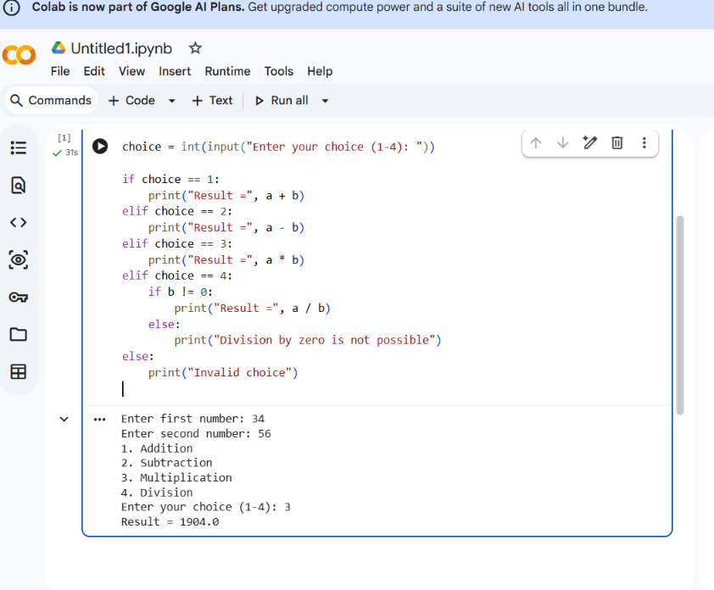
2. Python Program to Add Two Matrices
AIM
To write a Python program to add two matrices.
ALGORITHM
- Start the program.
- Get two matrices as input from the user.
- Add the corresponding elements of both matrices.
- Display the resulting matrix.
- Stop the program.
CODE

# Add Two Matrices

A = [[1, 2], [3, 4]]
B = [[5, 6], [7, 8]]

C = [[0, 0], [0, 0]]

for i in range(2):
for j in range(2):
C[i][j] = A[i][j] + B[i][j]

print("Matrix A:", A)
print("Matrix B:", B)
print("Sum of matrices:")
for row in C:
print(row)
OUTPUT:
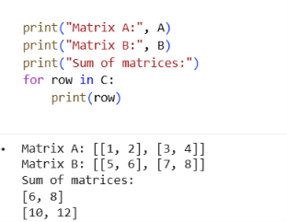
3. Python Program to Transpose a Matrix
AIM
To write a Python program to find the transpose of a matrix.
ALGORITHM
- Start the program.
- Define a matrix.
- Find the transpose by interchanging rows and columns.
- Display the transposed matrix.
- Stop the program.
CODE

# Transpose a Matrix

A = [[1, 2, 3], [4, 5, 6]]

print("Original Matrix:")
for row in A:
print(row)

T = list(zip(*A))

print("Transpose of Matrix:")
for row in T:
print(list(row))
OUTPUT:
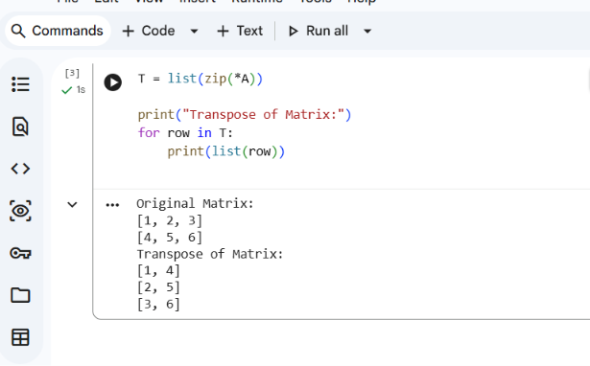
4. Python Program to Sort a Sentence in Alphabetical Order
AIM
To write a Python program to sort the words in a sentence in alphabetical order.
ALGORITHM
- Start the program.
- Get a sentence from the user.
- Split the sentence into individual words.
- Sort the words alphabetically.
- Display the sorted words.
- Stop the program.
CODE

# Sort a Sentence Alphabetically

sentence = input("Enter a sentence: ")

words = sentence.split()
words.sort(key=str.lower)

print("Words in alphabetical order:")
print(" ".join(words))
OUTPUT:
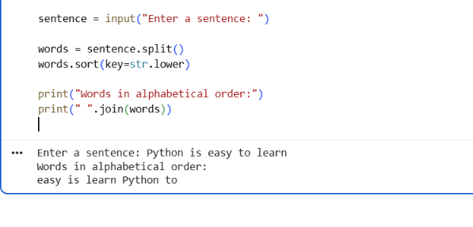
5. Python Program to Implement List Operations
AIM
To write a Python program to demonstrate list operations such as nested list, length, concatenation, membership, iteration, indexing, and slicing.
ALGORITHM
- Start the program.
- Create two lists and a nested list.
- Find the length of a list using len().
- Join two lists using +.
- Check membership using in.
- Display elements using iteration.
- Access elements using indexing.
- Extract elements using slicing.
- Stop the program.
CODE

# List Operations

L1 = [10, 20, 30, 40]
L2 = [50, 60]

# Nested List
nested = [1, 2, [3, 4]]
print("Nested List:", nested)

# Length
print("Length:", len(L1))

# Concatenation
print("Concatenation:", L1 + L2)

# Membership
print("20 in L1:", 20 in L1)

# Iteration
print("Iteration:")
for item in L1:
print(item)

# Indexing
print("First Element:", L1[0])

# Slicing
print("Slicing:", L1[1:3])
